**COMMIT PHASE**

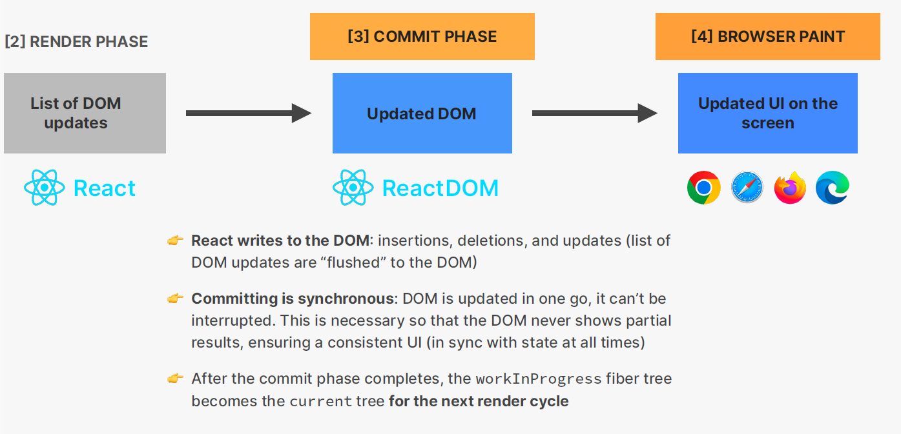

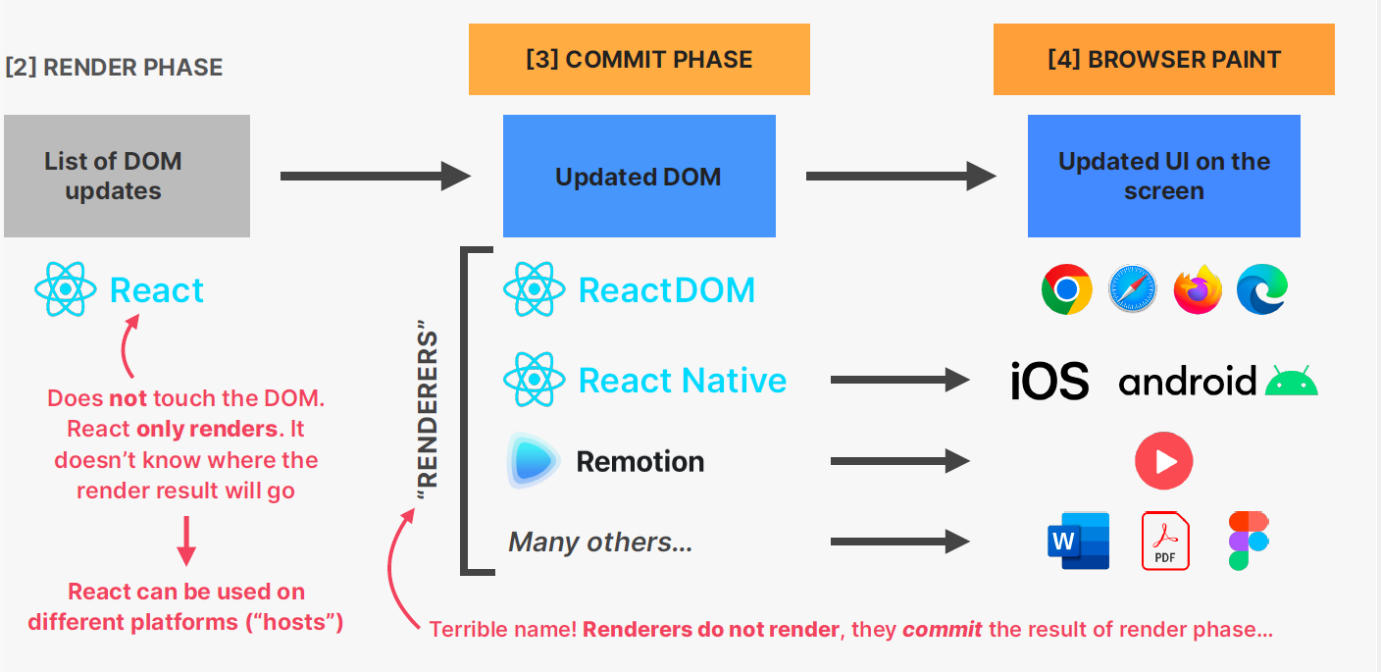

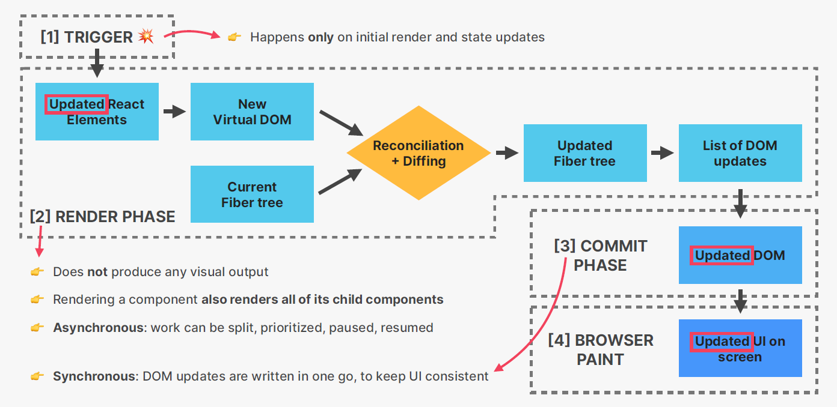

**Do you find it helpful?**

**Let me know down in the comments**



[](https://www.linkedin.com/in/anubhav-gupta-b68946132/)

**Click To Follow For More On LinkedIN**